KING JAMES I ACADEMY
PE BULLETIN

Ms J Humble Issue 35 October 2019

Rock Climbing

A group of 14 GCSE PE students were taken to Rof 59 at Newton Aycliffe to complete part of their practical assessment in rock climbing. Students participated in a range of activities including belaying, traversing and bouldering. Students worked exceptionally well and some even completed the overhang. This has ensured top practical grades for a number of students. A special mention to Dylan Nicholson and Bentley Lewis who performed really well and completed several really difficult climbs.

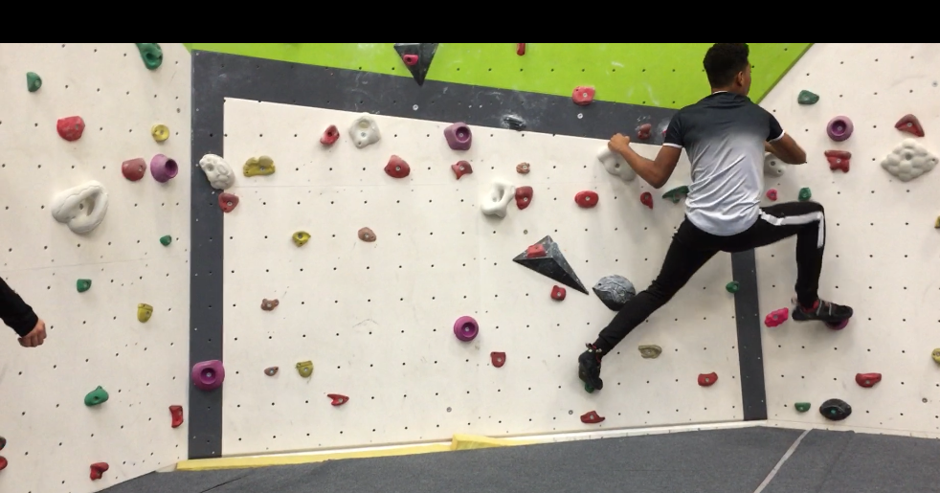

Cross Country

King James participated in the South West Durham cross country championships held at Barnard Castle on Thursday 17th October. King James entered both Junior and Inter teams for both boys and girls. Team results were good but there were some fantastic individual results. Brooks sowerby, Jake Dobinson, Kian Dixon, Jack Spencer and Tilly Robinson have all qualified have the district cross country championship. Well Done this is a fantastic achievement.

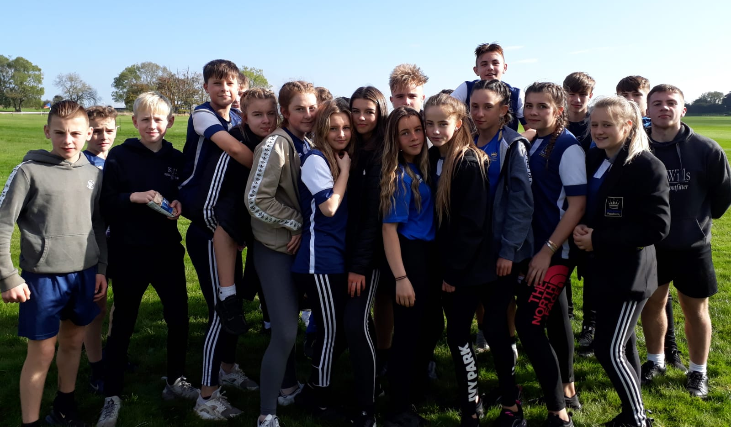

KS3 Curriculum (Nov-Dec)

GIRLS – Trampolining, Badminton and Fitness
BOYS – Trampolining, Badminton and Rugby

Football

The football season has started and King James teams have made a decent start to the season. Matches have taken place across all year groups. Year 7 have managed 2 wins against Ferryhill and Teesdale. The other year groups have put in some good performances, special mention to Romario Fraser who has selected for the Bishop Auckland District team. Training is taking place on a Monday night after school from 3.30 – 4.30, attendance is good but we welcome anyone else with an interest or a talent to come along and develop their skills

Netball

The netball season has started and King James has made a decent start to the season. Matches have taken place both home and away for the year 9 team with mixed results. They have won against Staindrop and Wolsingham. Well Done! Year 7 have been attending training and are starting to improve in both skills and tactics ready for their matches in January. If you are interested in joining the team just turn up for practise on a Tuesday afterschool and take part in training.

