KING JAMES I ACADEMY
PE BULLETIN

Ms J Humble Issue 34 July 2019

Student of the Term

Each PE teacher nominated a student for summer student of the term. These students were awarded with a certificate and a community voucher for the use of free classes and facilities. Congratulations to these students.

Year 7 Girls = Katie Preston
Year 7 Boys = Justin Breward
Year 8 Girls = Casey Foster
Year 8 Boys = Kieran Howarth
Year 9 Girls = Ebony House
Year 9 Boys = Kieran Grafton
Year 10 Girls = Millie Simpson
Year 10 Boys = Dylan Howe

Continue to try hard in your PE lessons and attend afterschool clubs to try to win student of the term next term.

Mountain Biking

A team of 4 boys and 4 girls participated in a mountain biking competition at Teesdale School on Tuesday 18th June. John from British Cycling coached the students through gear changes and tactics of racing and they participated in a number of races including a relay and an endurance event. King James won the competition and have now earned their place in the level 3 finals to be held at Maiden Castle on Friday 5th July. At Maiden Castle King James girls came 2nd and the boys finished 4th. A special mention to Konnie Grace Sowerby who finished 3rd out of all of the girls attending the final and Harley Jones who finished 6th. Well done to the whole team.

T

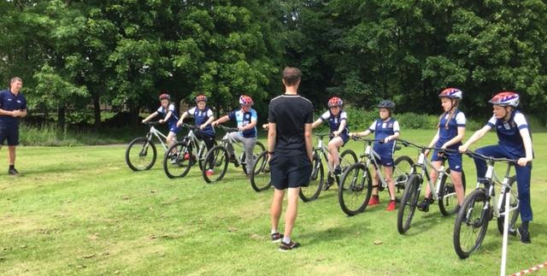

Yr7 Athletics

A team of 7 boys and 7 girls from year 7 participated in a triangular athletics tournament at St. Johns school. They participated in events such as shot putt, long jump and the medley relay for points against St Johns and Barrington. The boys finished 3rd in their competition and the girls were joint winners well done to all participants.
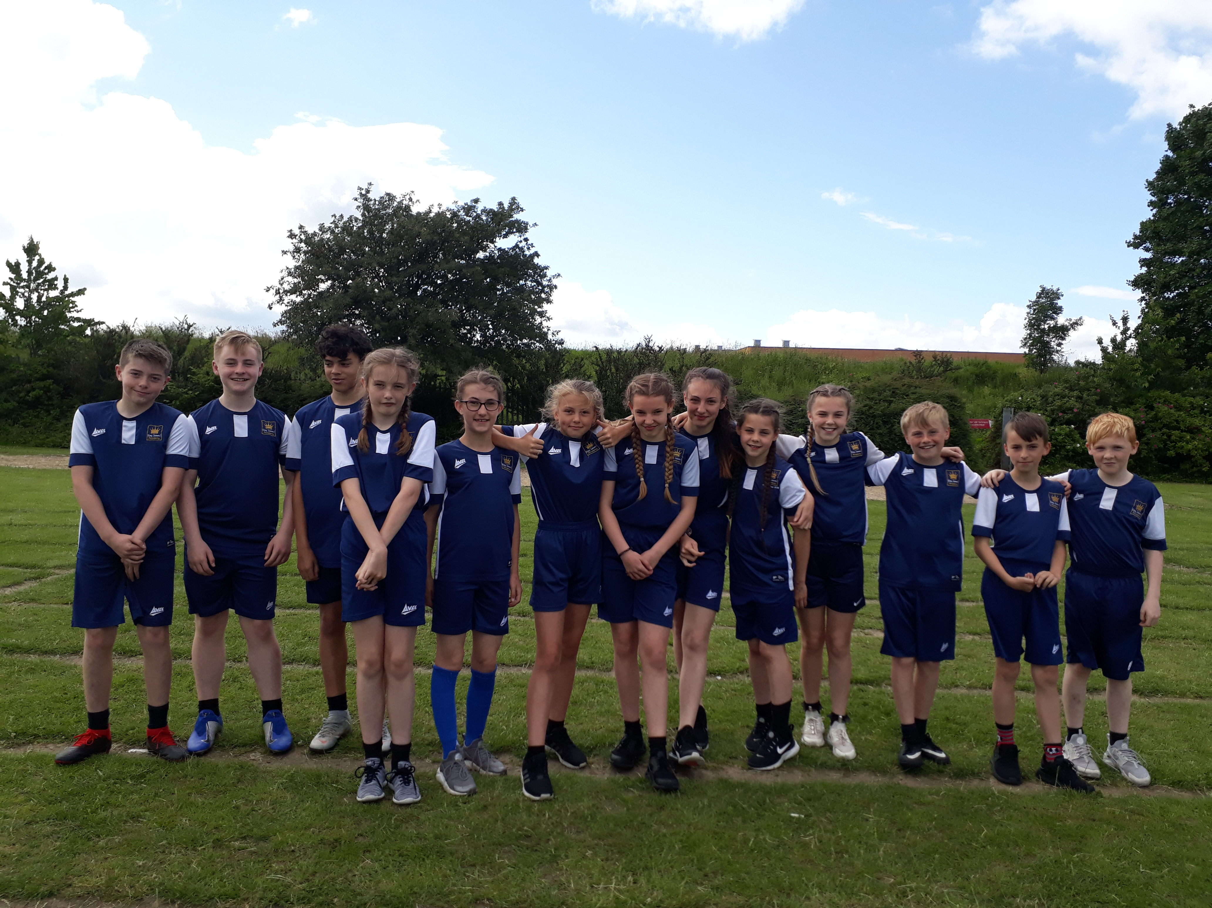

KS3 Curriculum (Sept-Oct)

GIRLS – Netball, Baseline and Hockey
BOYS – Football, Badminton and Baseline

Leeds Becket University 6th Form Trip

Year 12 sports students have been invited to attend Leeds Becket University to participate in workshops relating to a sports and exercise degree. This is to motivate them to aim higher and inspire our students to pursue higher education. After an introductory speech about the sport courses that the Uni offer the students attended 3 sessions. The first session was playing wheelchair basketball. The students were taught how to play the game and played the game in wheelchairs that cost £1000 each. Next they had a session on sports coaching and they learned how to aim a session at young students. After dinner they had a tour of the campus and then did their final session on physiology. One student rode a bike and had his details tracked regarding oxygen consumption, CO2 expenditure and heart rate.

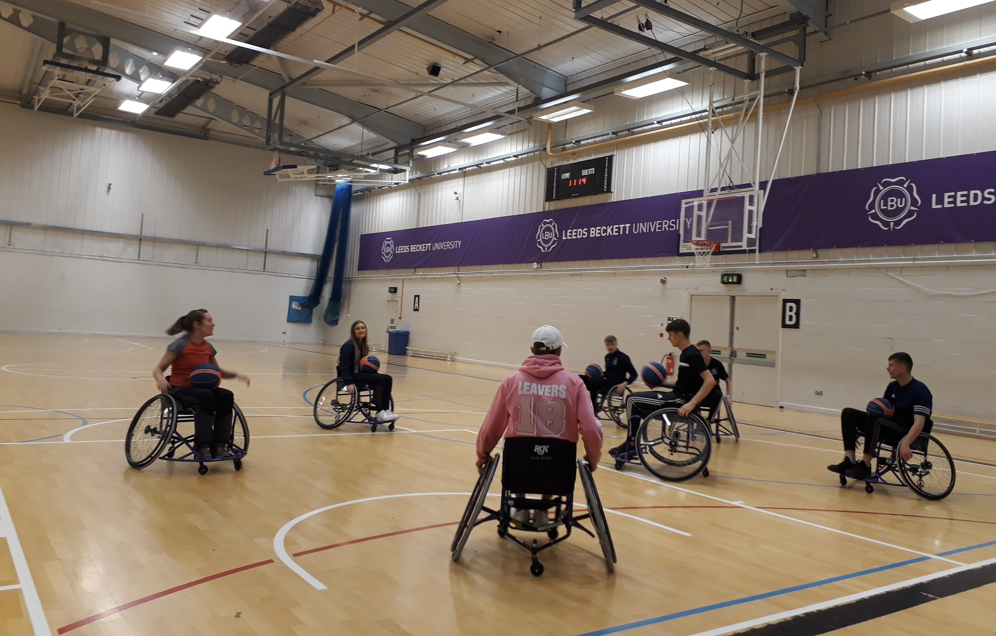
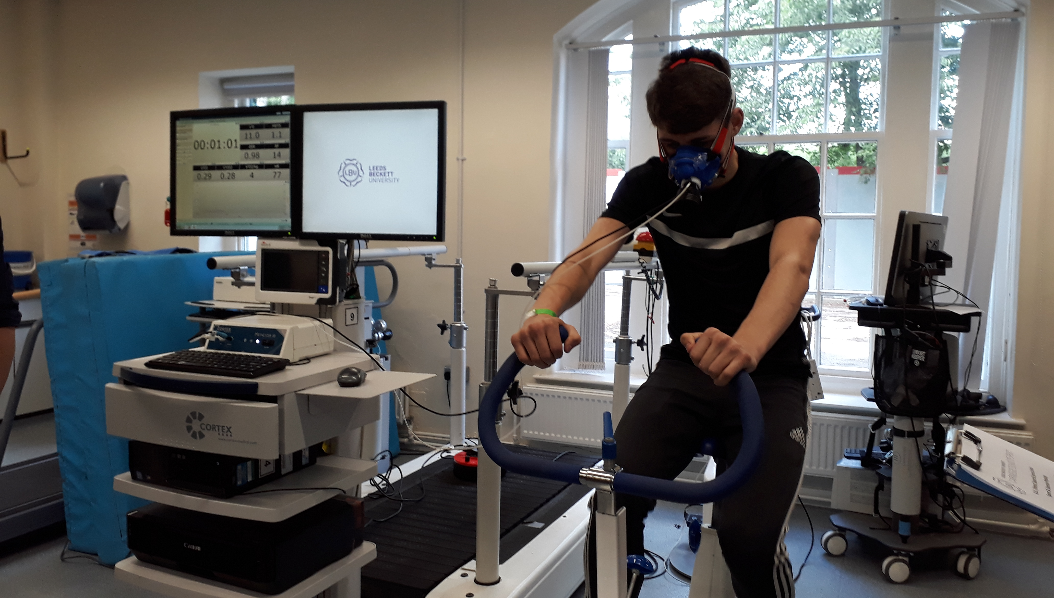
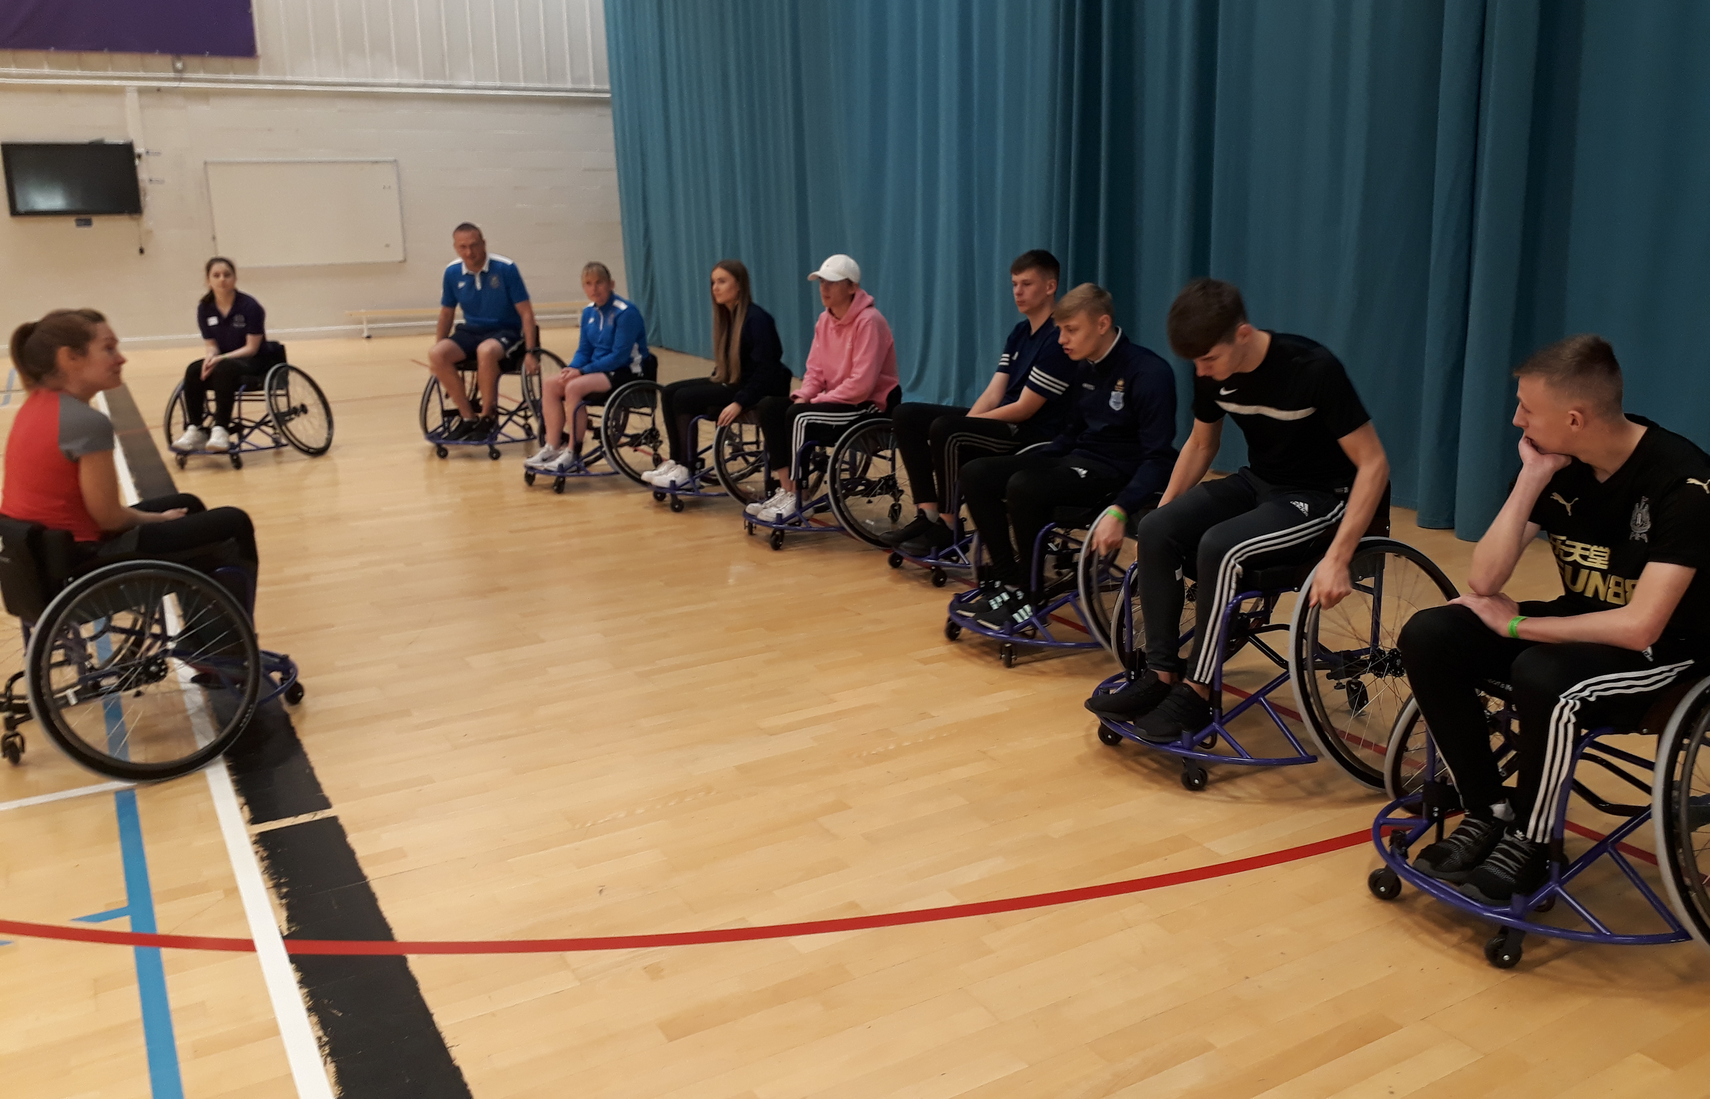

Wimbledon

8 students and 2 staff visited Wimbledon this half term. They spent 2 days at London doing various activities such as visiting Madame Tussauds and shopping but the main event was attending Wimbledon and watching some fantastic tennis on centre court. Both staff and students had participated in various fund raising activities to reduce the cost of the trip and then thoroughly enjoyed the experience. The department hope to run this trip again next year.

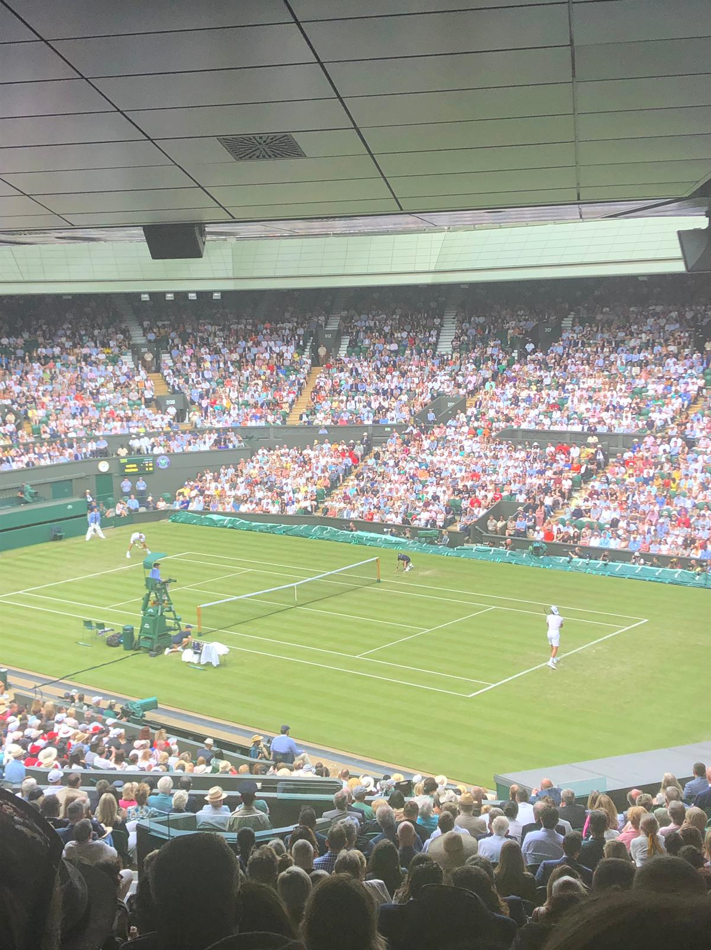

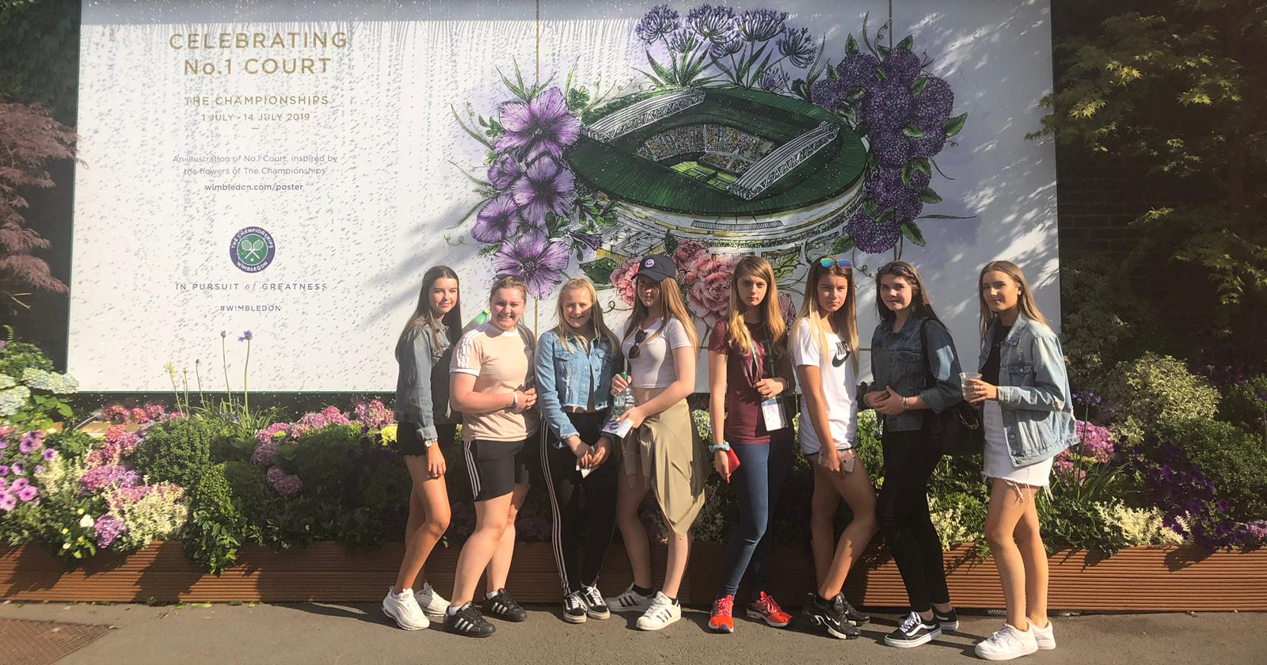

Rounders

Year 8 participated in a rounders tournament at Staindrop and competed against Parkside and Staindrop. King James beat Staindrop and drew against Parkside meanin g they won the competition overall. They also participated in a game of magic rounders which King Jmaes also won. Well Done to all participants and congratulations to the whole team.

