KING JAMES I ACADEMY
PE BULLETIN
Ms J Humble March 2024

Boys Football
Year 7 boys have come back after Christmas and are on an unbeaten run; they beat Parkside 9-1, Whitworth 5-2 in a cup quarter final and beat Staindrop 7-3. Well done boys keep it up.
Year 8 boys have had mixed results with a narrow defeat to Parkside 1-0 but an excellent win over Staindrop 14-2. Year 9 lost to Parkside 9-3.
Year 10 have played numerous fixtures including a futsal tournament where they won one and lost one, they drew 2-2 with Dyke House School (County Cup Quarterfinals) and eventually won on penalties. They won 5-0 against Parkside but seem to have lost form due to a number of key players being injured and lost 3-0 against Houghton Kepier in the County Cup semi-finals and Lost 7-1 to Wolsingham.
Year 11 Won 3-0 against Woodham School in the cup quarter-finals and proceed to the next round. A solid effort from all teams!
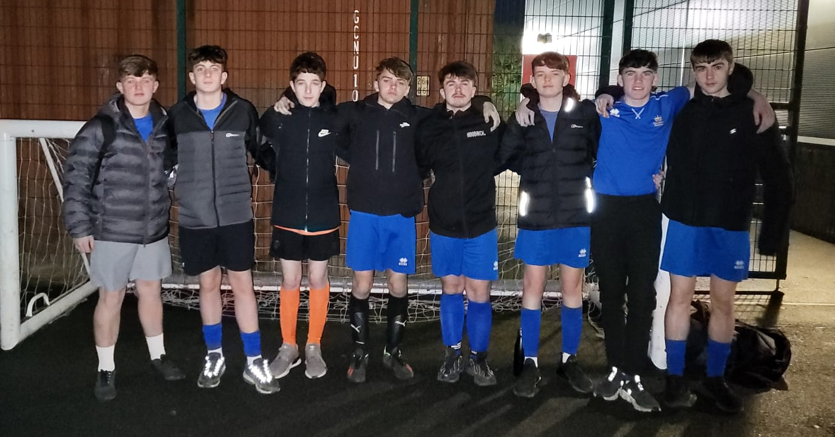
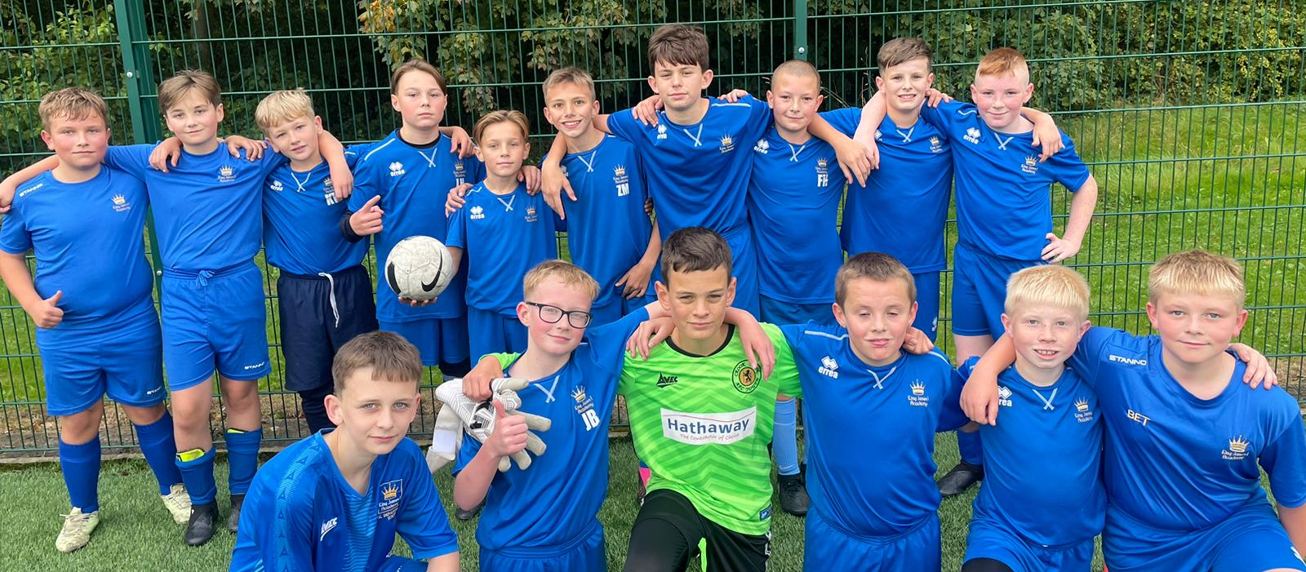
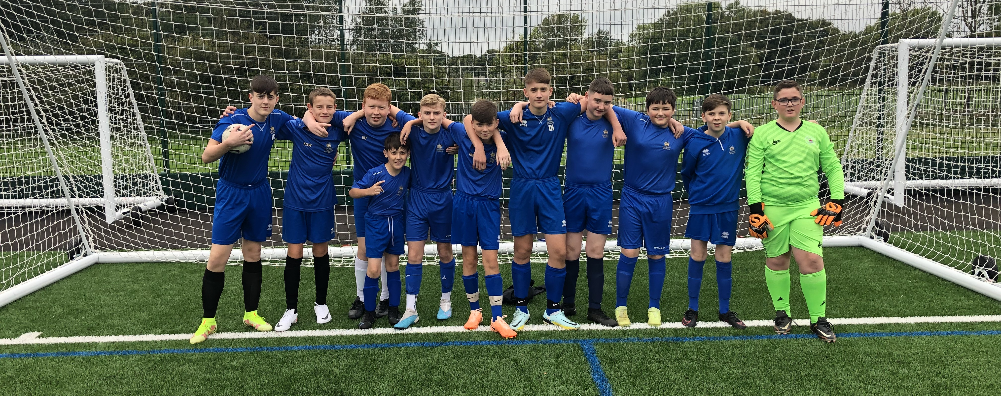
Year 11 Rock Climbing

Year 11 GCSE PE students completed their rock-climbing assessment. The students worked hard to demonstrate a range of skills and techniques such as step throughs, tying on and belaying and secured fantastic results which will count towards their final grade.
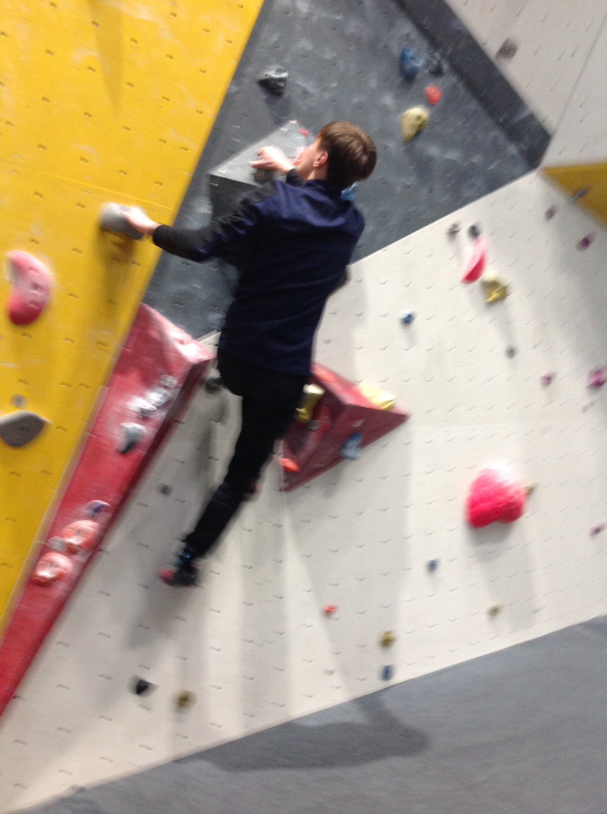

Student of the Term

Each PE teacher nominated a student for spring student of the term. Congratulations to these students.

Year 7 Girls = Annalise Moore
Year 7 Boys = Oliver Burke
Year 8 Girls = Aaliyah Clarkson Gibson
Year 8 Boys = Luke Thompson
Year 9 Girls = Briar Rose Howard
Year 9 Boys = Jack Liddle
Year 10 Girls = Autumn Grace Kelly
Year 10 Boys = Justin Fitt
Year 11 Girls = Amber Roe
Year 11 Boys = Lucas Heels
6th Form = Eric Kovaci and Katie Rutherford
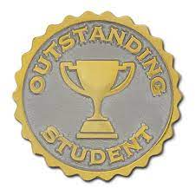

KS3 Curriculum (April - May)

GIRLS – Basketball and Athletics.
BOYS – Softball and Athletics.

