KING JAMES I ACADEMY
PE BULLETIN
Ms J Humble March 2023

Year 7/8 Girls Futsal

The 7/8 Girls Futsal team played in the regional final’s tournament held at Easington School having qualified after winning the local tournament. The girls performed really well against some tough competition and finished second overall. Well done girls!!

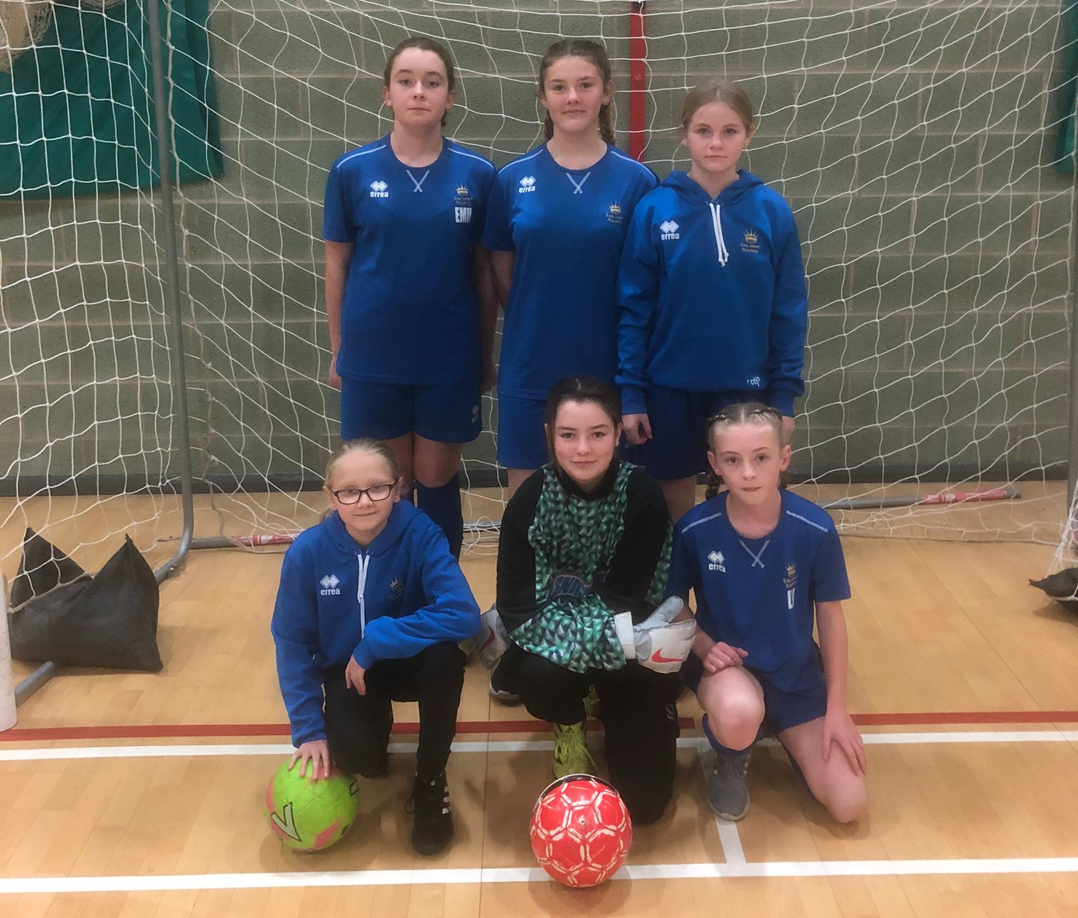
Yr8 Girls Netball
Year 8 Girls have been competing in the local school’s netball league. After a bad start losing to St. Johns the girls have put in some fantastic performances beating Parkside 5-3, Greenfield 10-2 and Whitworth 7-3. Well done to all the girls for fantastic effort and determination.
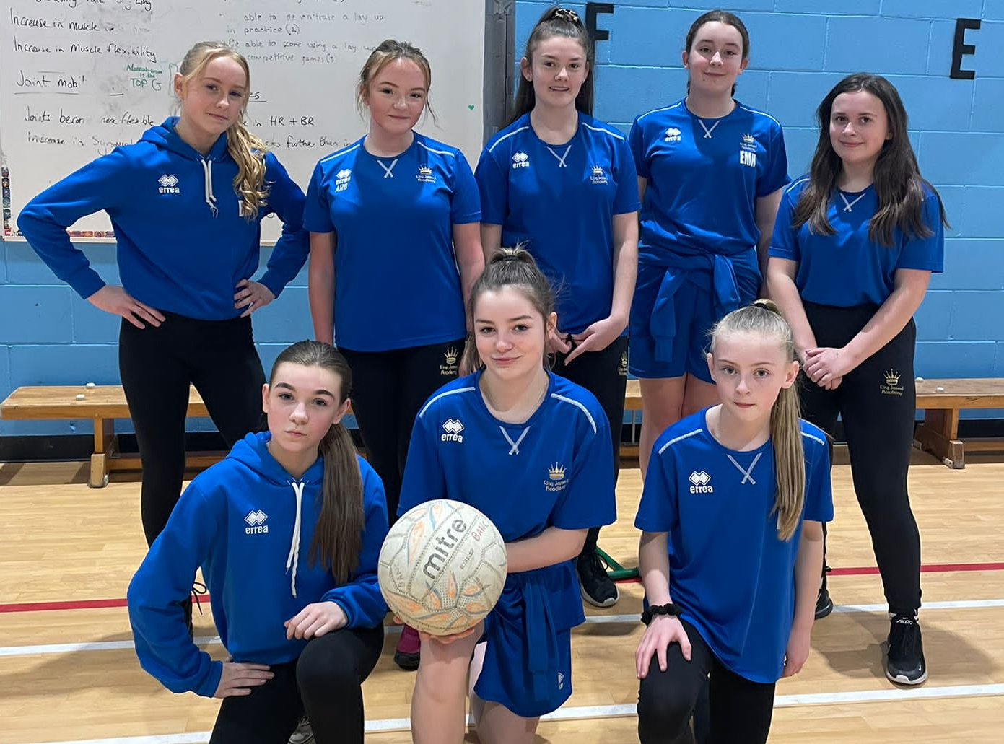

Student of the Term

Each PE teacher nominated a student for spring student of the term. Congratulations to these students.

Year 7 Girls = Olivia Bowskill
Year 7 Boys = Reece Tinkler
Year 8 Girls = Emma Hawman
Year 8 Boys = Evan Hymas
Year 9 Girls = Shannon Calvert
Year 9 Boys = Bezaleel Umoru
Year 10 Girls = Lori Leigh Turner
Year 10 Boys = Farhyn Brown
Year 11 Girls = Michaela Fitzgerald
Year 11 Boys = Joji Basudra
6th Form = Coban stamp
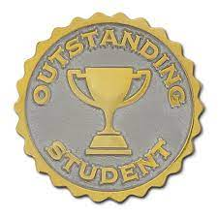


Level 3 Athletics

Year 7 boys represented the academy at the sports hall athletics school games held at Newton Aycliffe Leisure Centre in February having won the local event in November. They competed against other schools in the county such as Tanfield and Easington. Although they worked hard with some fantastic individual performances they finished 5th overall. Well done to all the boys!
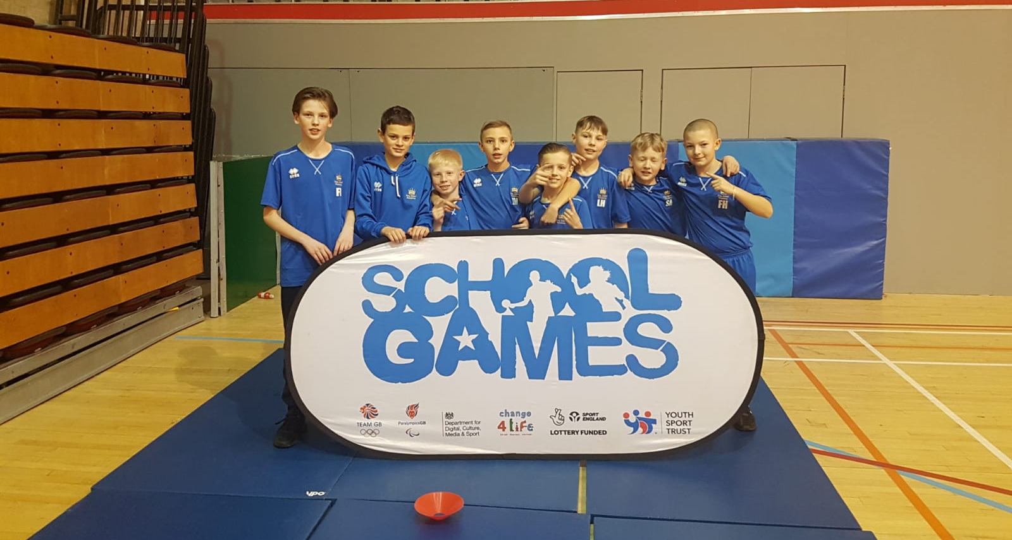

KS3 Curriculum (Apr-May)

GIRLS – Basketball and Athletics.
BOYS – Cricket, Softball and Athletics.

