KING JAMES I ACADEMY
PE BULLETIN
Ms J Humble December 2022

Football
King James football teams have played a number of fixtures with mixed results.
Year 10 Boys Football Team (2022-2023) Beaten 4-1 by Wolsingham. Beaten 4-0 by Sedgefield. Beaten 4-0 by Parkside. Drew 7-7 against Whitworth
Year 9 Boys Football Team (2022-2023) Beat Wolsingham 4-1 in the Cup. Beat Sedgefield 2-0. Beat Parkside 6-2. Beat Ferryhill 2-0. Lost 5-1 against Whitworth. Lost 2-1 against Wolsingham
Year 8 Boys Football Team (2022-2023). Beaten by Sedgefield 4-1. Beaten by Greenfield 5-1.
Year 7 Boys Football Team (2022-2023) Lost 2-1 to Whitworth in the Cup. Beat Parkside 5-1. Beat Ferryhill 3-2. Beat Greenfield 5-1. Drew 3-3 against Whitworth.
Well done to all students who have represented the academy. Fixtures recommence after the Christmas break.

Yr8 Girls Futsal

Champions!!!! Year 8 Girls competed in the futsal competition for the Bishop Auckland district area. They beat Durham Johnston 5-0 and Whitworth 3-0 in the group stage. In the semi-final they beat Teesdale 3-1 and then beat Durham Johnston 2-1 in the final. They will go on to represent the Bishop Auckland District in the next round. Well done Eve H, Leah B, Kadyn G, Alisha G, Sophie D and Leyla V.
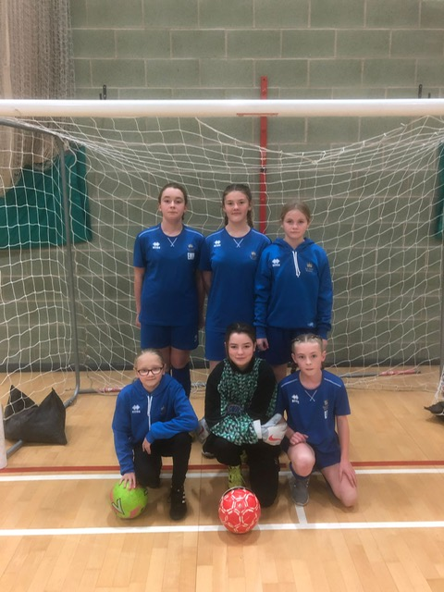

Student of the Term

Each PE teacher nominated a student for winter student of the term. Congratulations to these students.

Year 7 Girls = Sophie Douthwaite.
Year 7 Boys = Zac Moffat.
Year 8 Girls = Alisha Garrett.
Year 8 Boys = Reece Robson.
Year 9 Girls = Molly Johnson.
Year 9 Boys = Tyler Howat Powell.
Year 10 Girls = Amber Roe.
Year 10 Boys = James Chadwick.
Year 11 Girls = Lily Tinkler.
Year 11 Boys = Lachlan Plews.
Year 12 = Jake Baldwin.
Year 13 = Brendan Lowe.

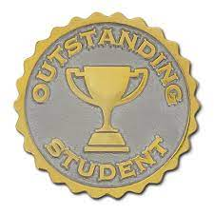
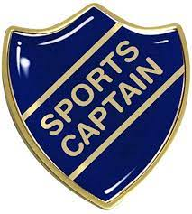
Sports Hall Athletics

Year 7 and 8 boys and girls represented the academy in teams at various events on the 8th November at Bishop Barrington school. There were numerous indoor athletics events including 6 lap relay, speed bounce and shot. All students made a fantastic effort resulting in Year 7 boys finishing first. Year 7 girls finishing second. Year 8 boys and girls finishing third. The year 7 boys team now go onto to the level 3 competition, date to be announced. Well done to all competitors.
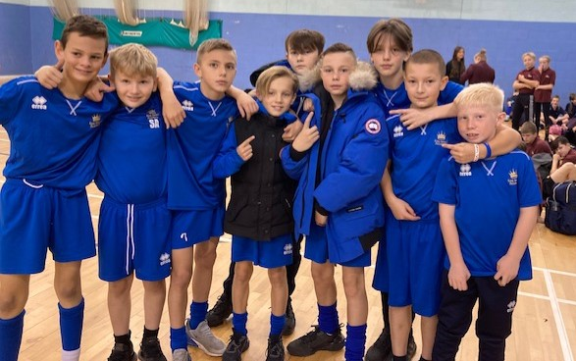

KS3 Curriculum (Jan-Mar)

GIRLS – Trampolining, Badminton, Dance and Tag Rugby.
BOYS – Trampolining, Badminton and Fitness.

Cross - Country

The cross-country championships were held at Barnard Castle School this term. There were numerous team competitions including year 7 boys and girls, junior girls and boys (year 8/9) and inter girls and boys (year 10/11). Unfortunately teams didn’t place but there were some fantastic individual performances. The following students placed top 16 and have qualified for a county competition held in January.
Konnie Grace Sowerby 4th
Jack Liddle 5th
Zac Moffat 11th
Well done to all competitors but a special congratulations to the students representing the academy at county trials.

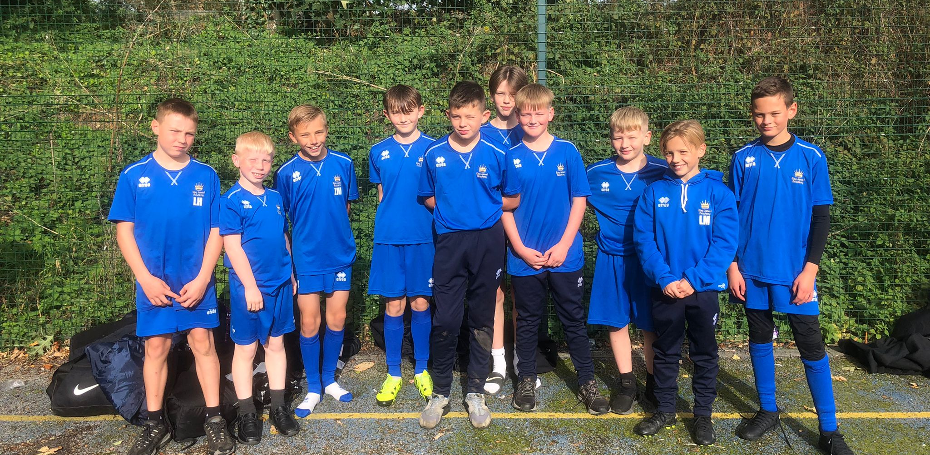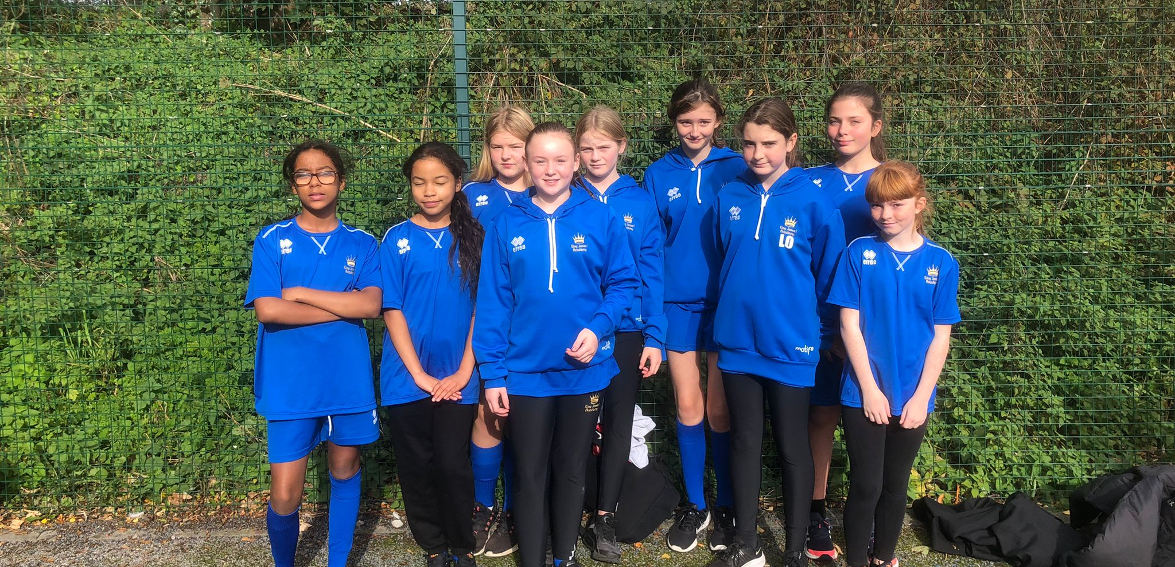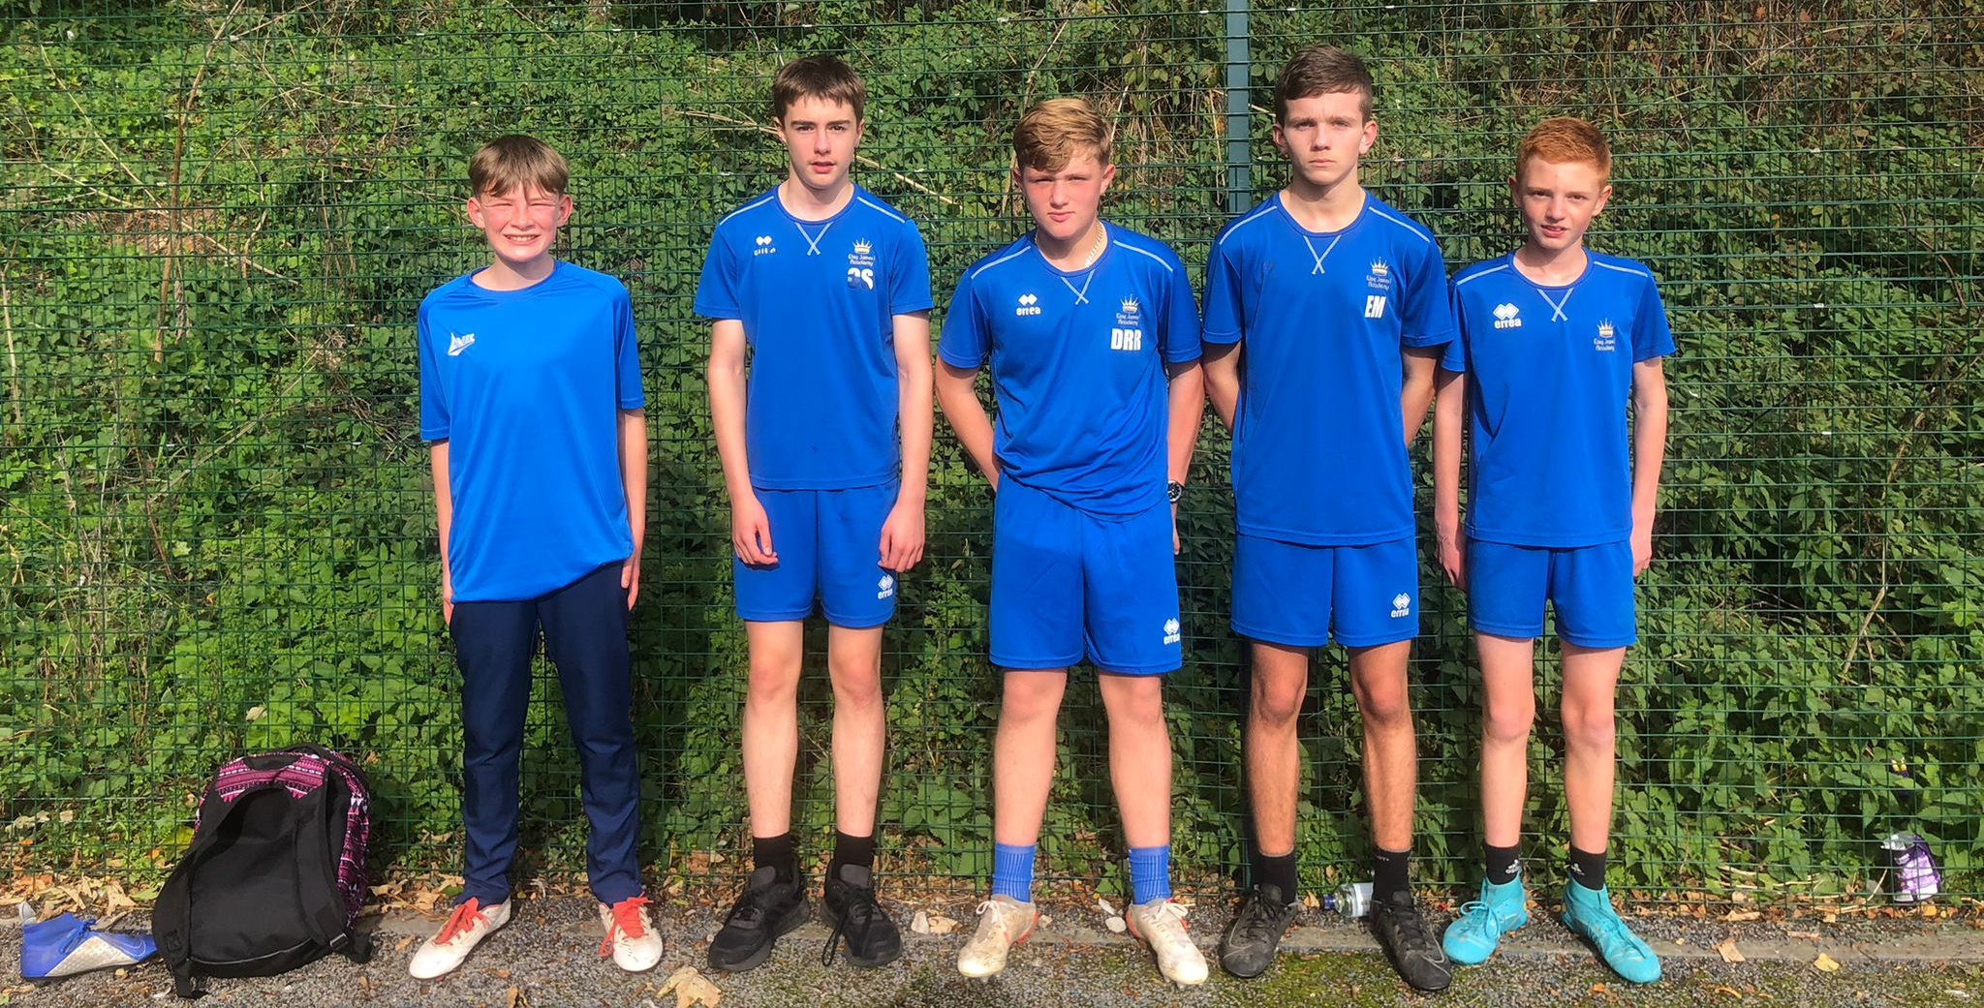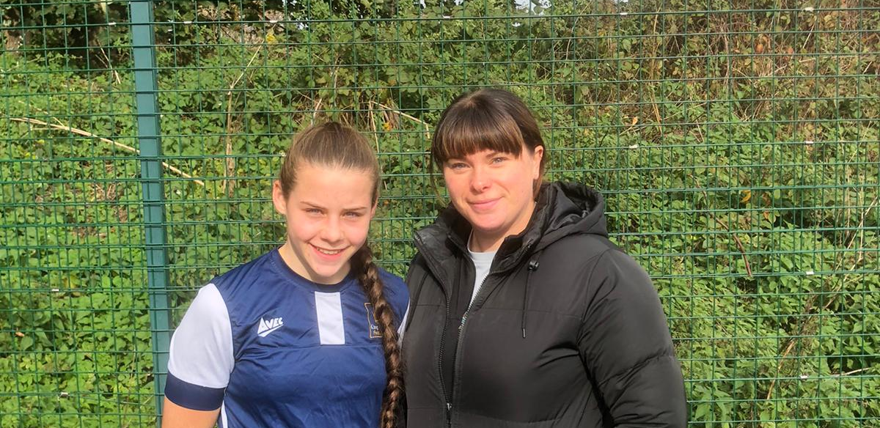

GCSE Rock Climbing
12 GCSE PE students were taken to ROF 59 (Rock Antics) to complete their GCSE assessment in Rock Climbing on Wednesday 2nd November. They completed various activities including bouldering, traversing, tying on, belaying and various climbs some with a high level of difficulty. They worked hard all day and all successfully passed their assessment.

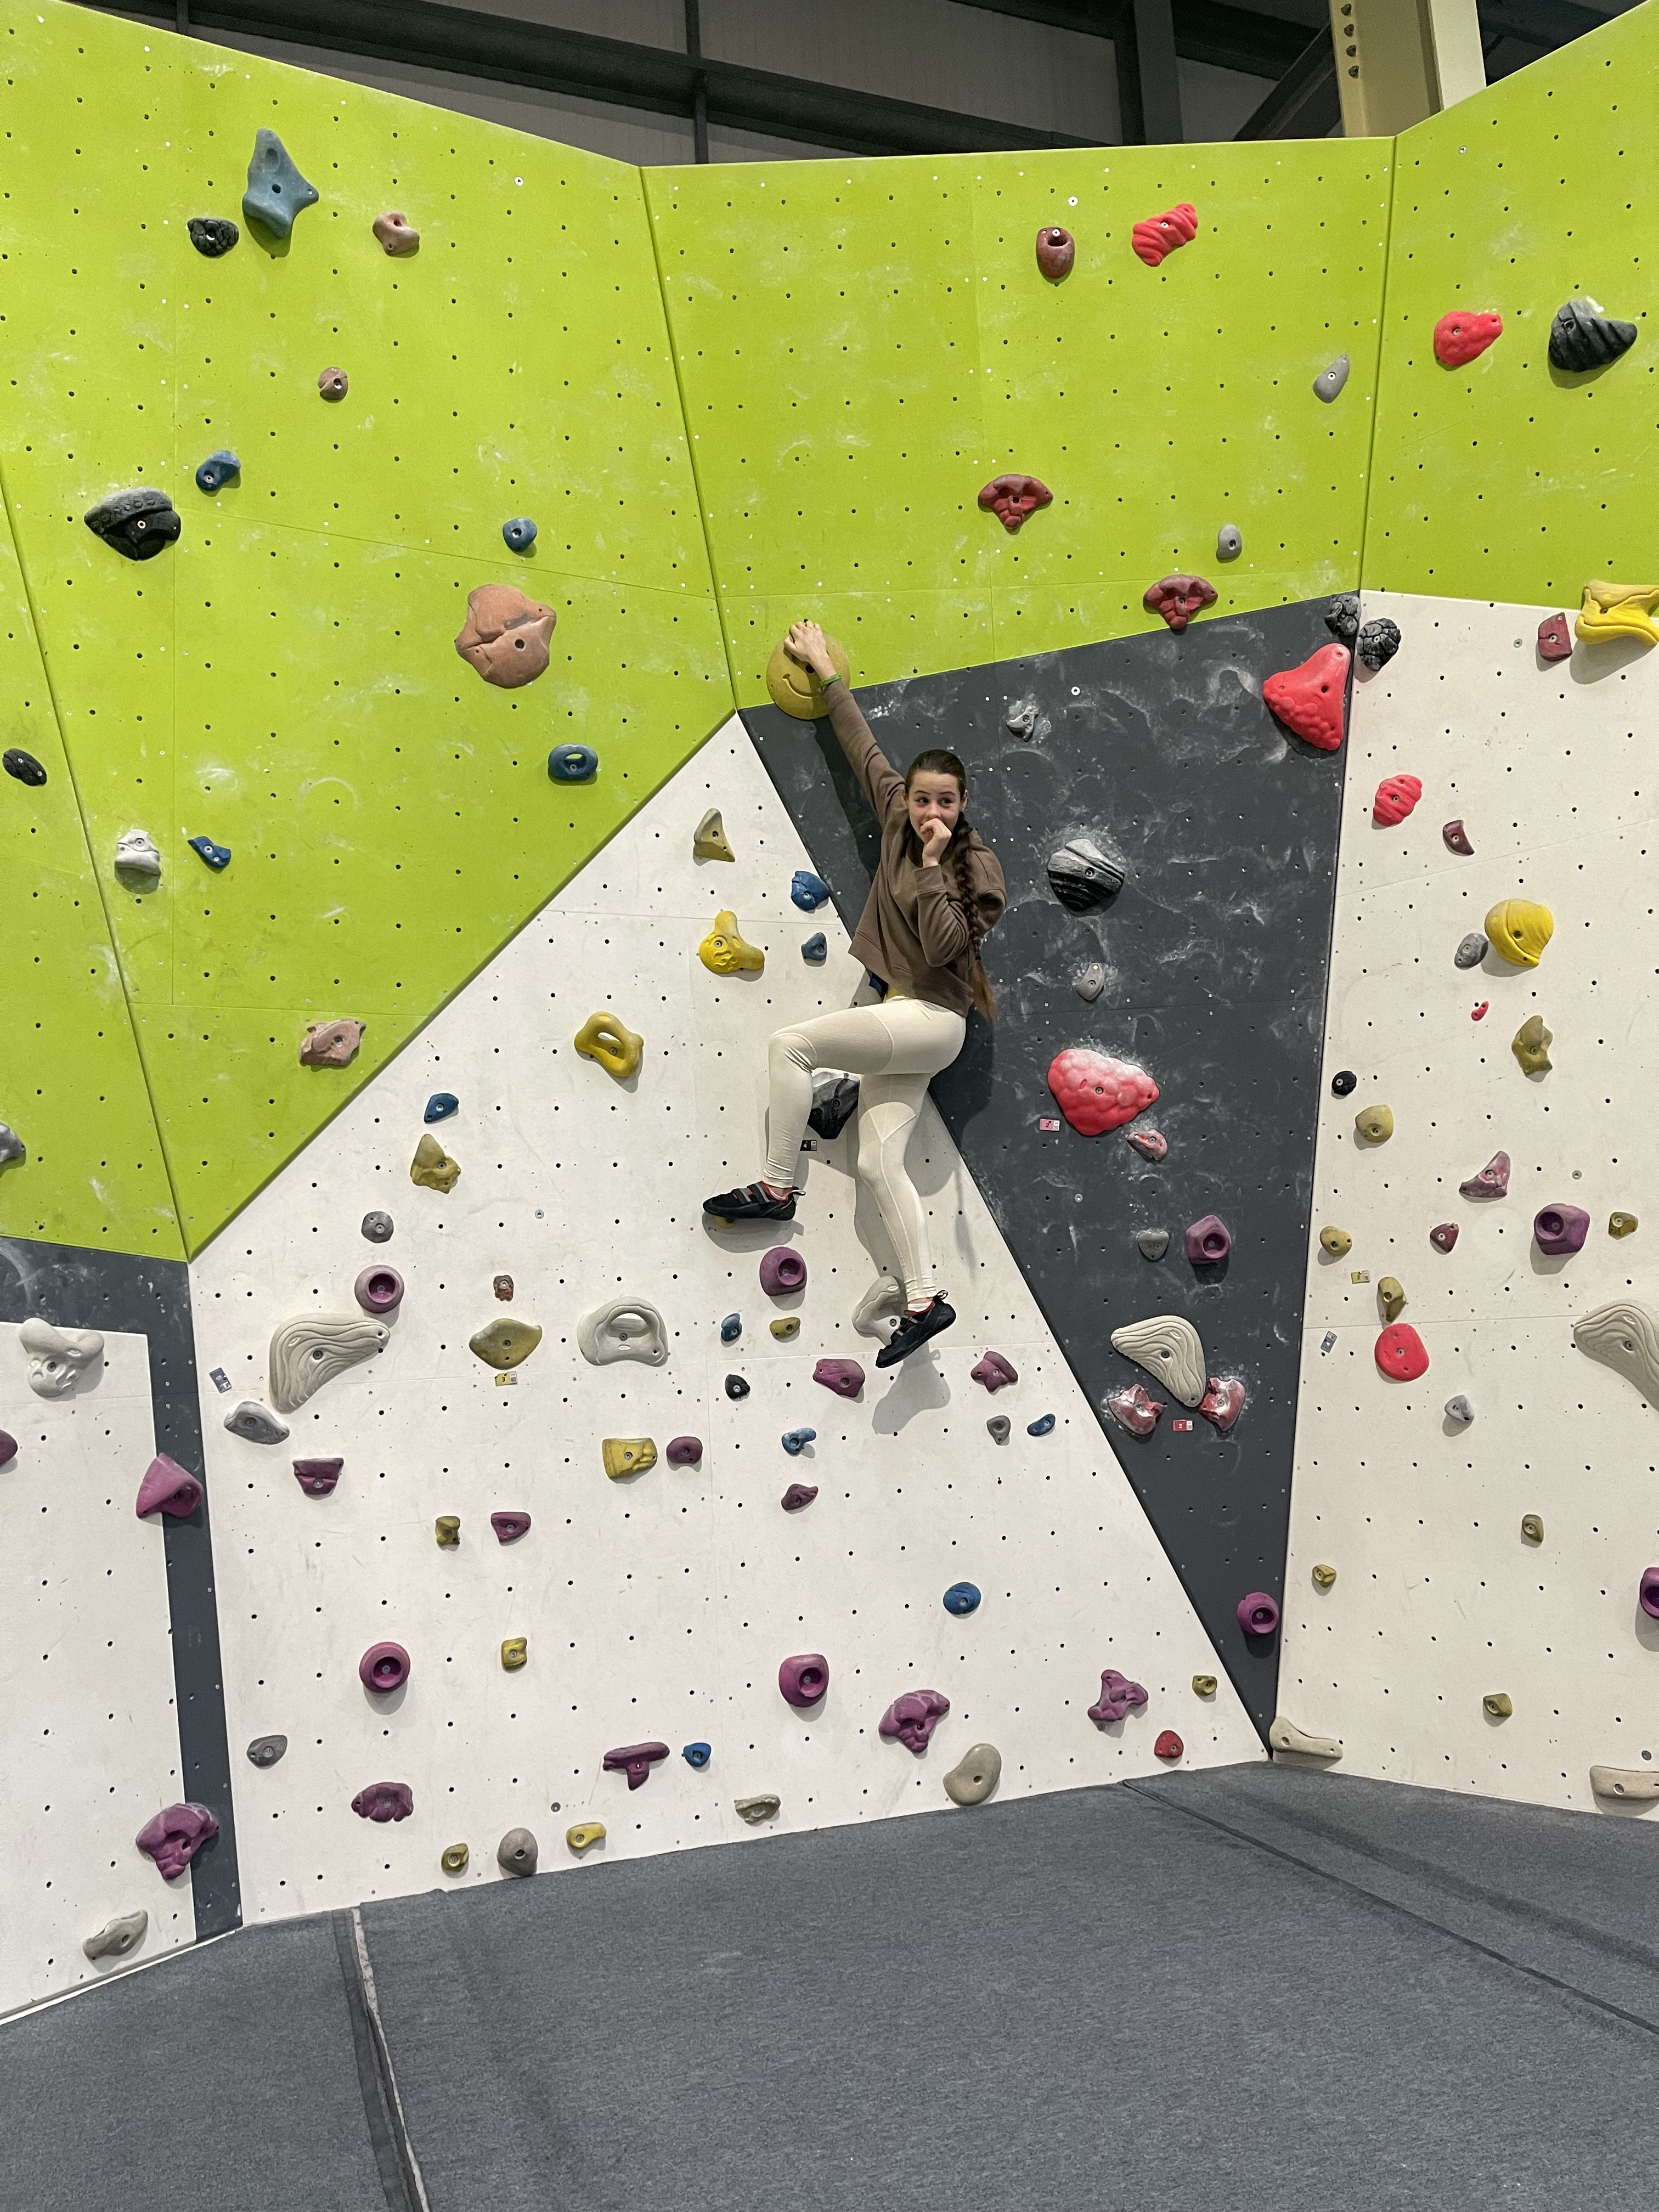

Yr8 Badminton

Year 8 students played in a Badminton tournament held at King James 1 Academy. Having played numerous matches and demonstrating solid skills and techniques they finished second overall. Well done to James Agnew and Cameron Raamsalu.

