KING JAMES I ACADEMY
PE BULLETIN
Ms J Humble April 2026

Level 2 and 3 Courses

CTECH Level 3 students attended Rock Antics for evidence for unit 18 practical performance and achieved fantastic results. In addition, Bishop college came and spoke to sixth form about the sports coaching degrees they offer as an incentive for students to get results and think about progression. Level 2 BTEC students got their exam results in March with the majority attaining their target grade. Well Done to Year 11 BTEC students who have now completed their course.

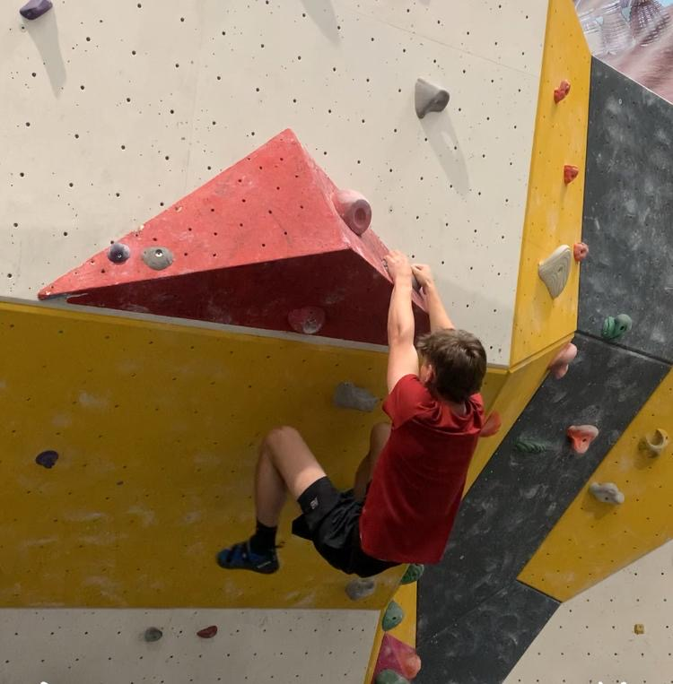

Year 8 Netball

Year 8 have taken part in matches and a tournament this term. Winning all individual matches and coming joint second in the tournament in a closely fought competition. Special mention to Gracie Slater and Charlie Sawczyn for players of the match/tournament. Well Done Girls! Fantastic effort!!
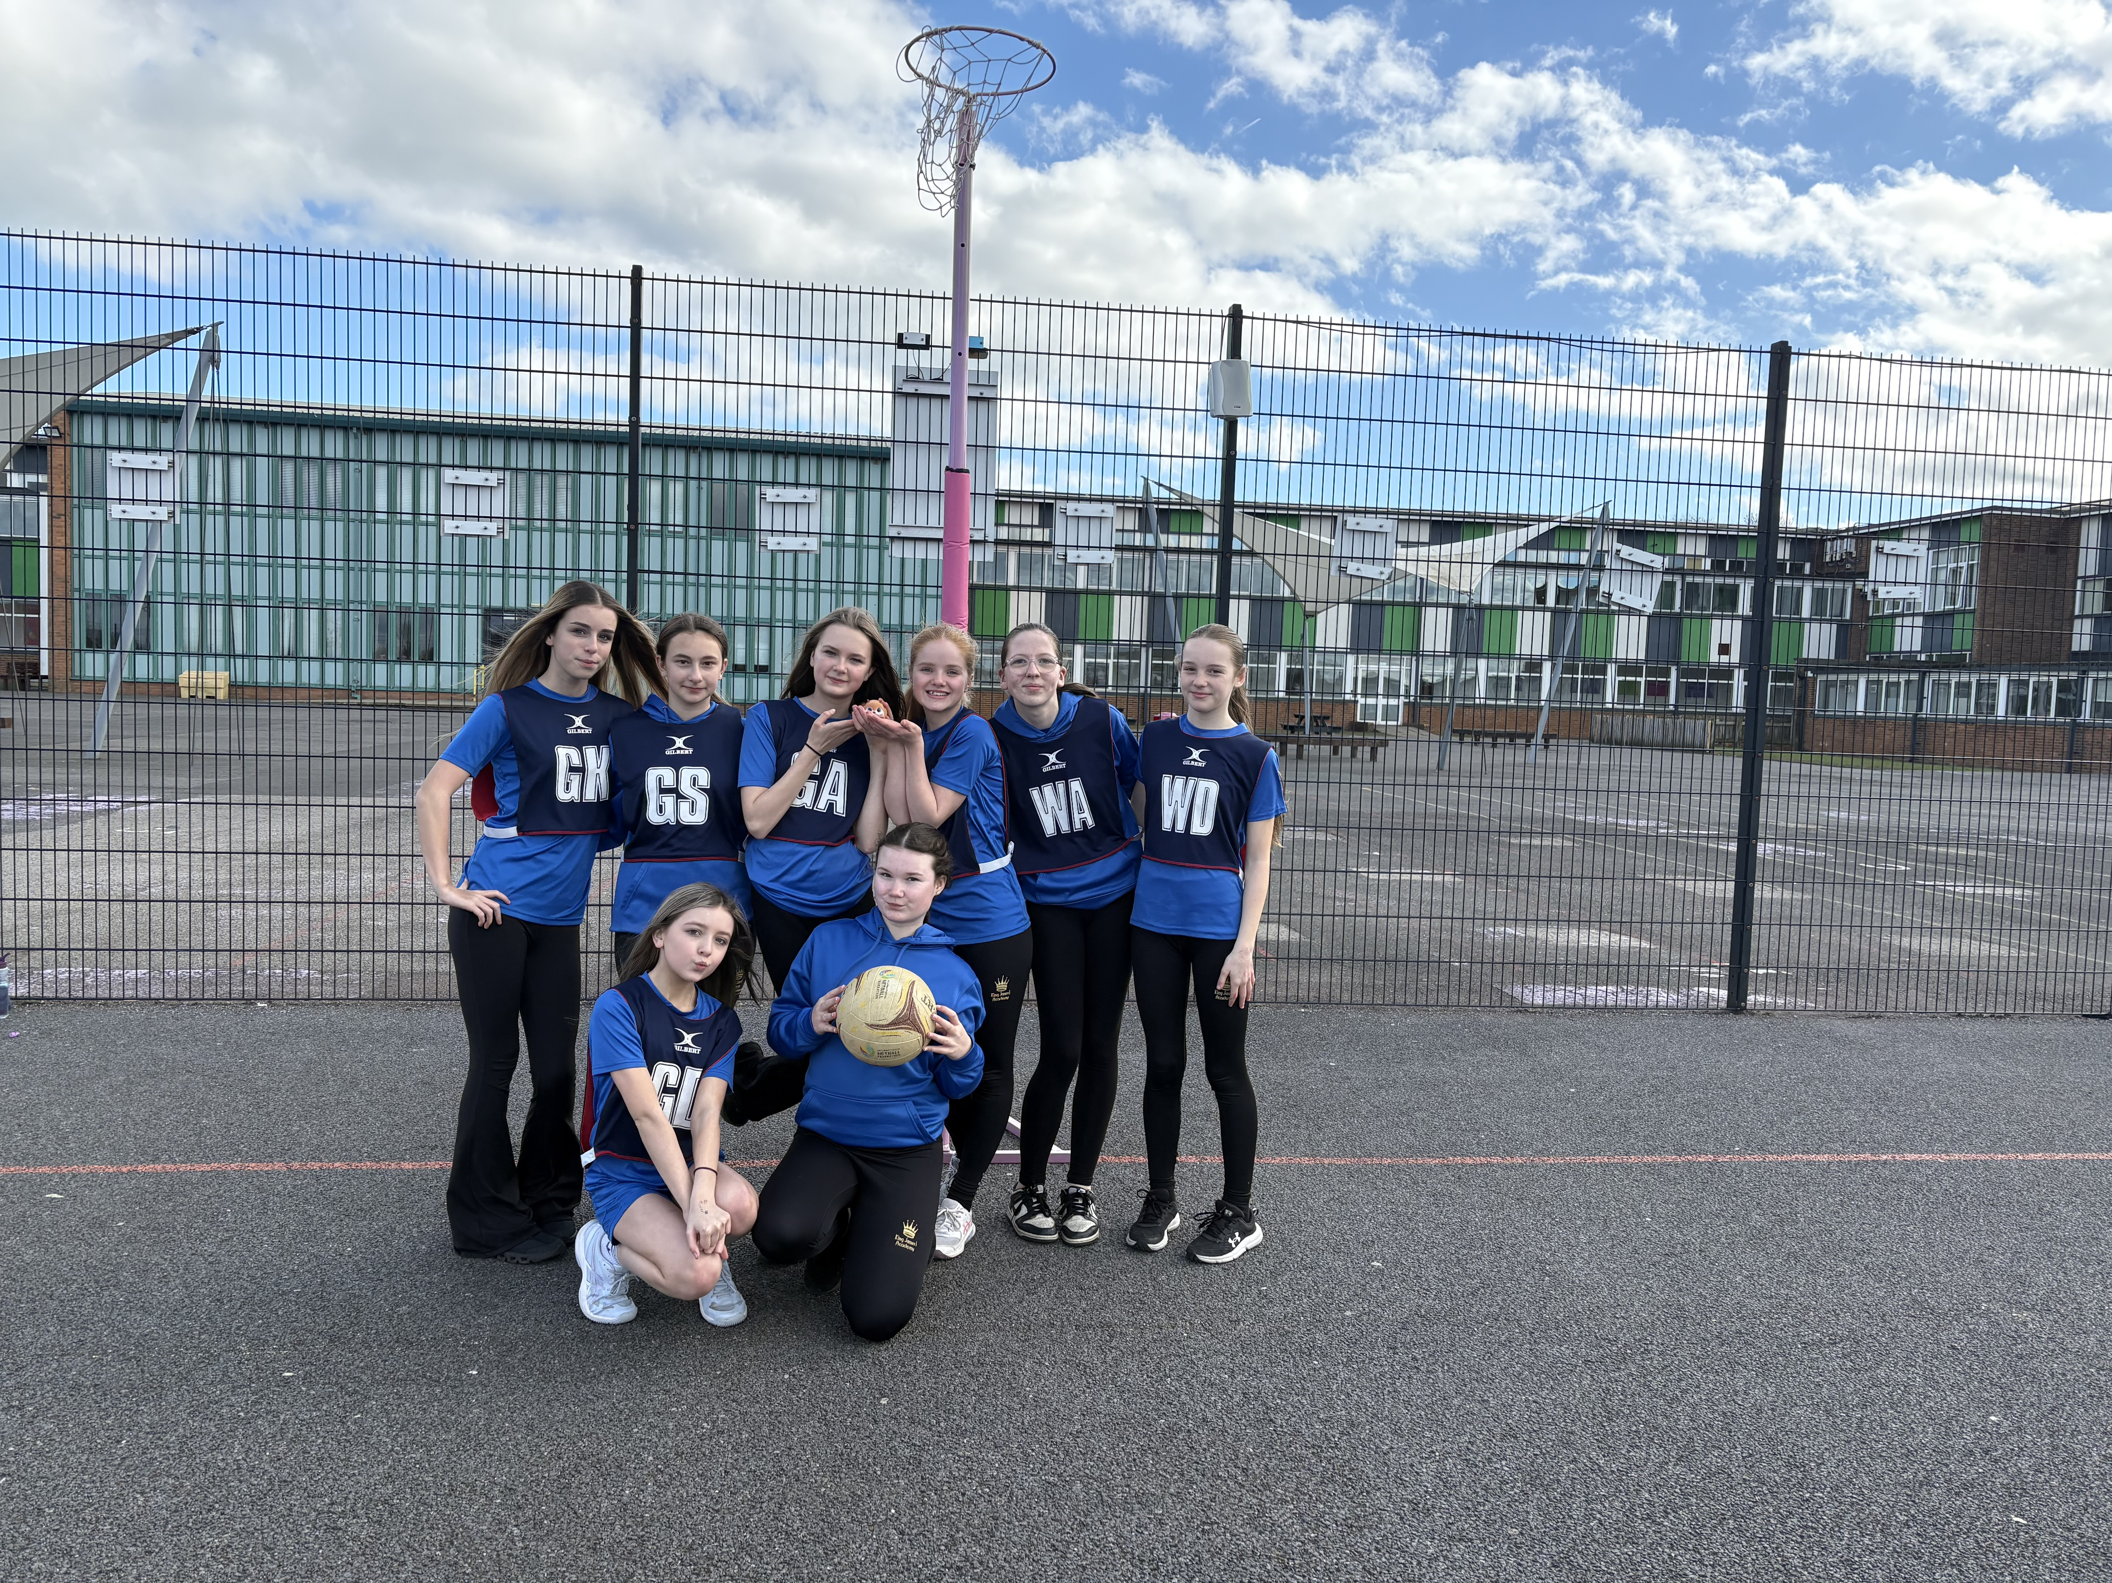

competitors who represented the academy.

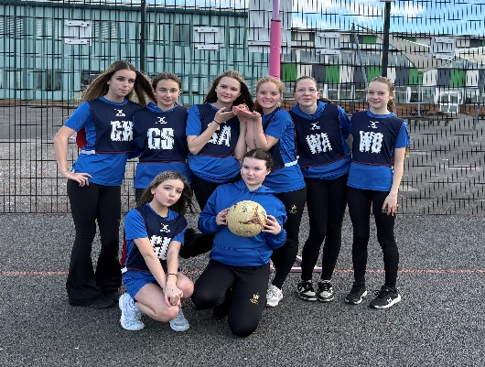

Student of the Term

Each PE teacher nominated a student for spring student of the term. Congratulations to these students.

Year 7 Boys – Jacob Sawczyn
Year 7 Girls – Amelia Ward
Year 8 Boys – Thomas Morgan
Year 8 Girls – Charlie Sawzcyn
Year 9 Boys – Jayden Atkinson
Year 9 Girls – Kaitlyn Rutherford
Year 10 Boys – Mathew Macauley
Year 10 Girls –. Lilly Blacklock
Year 11 Boys – Evan Hymas
Year 11 Girls – Charlotte Davidson
6th Form – Lewis Mason

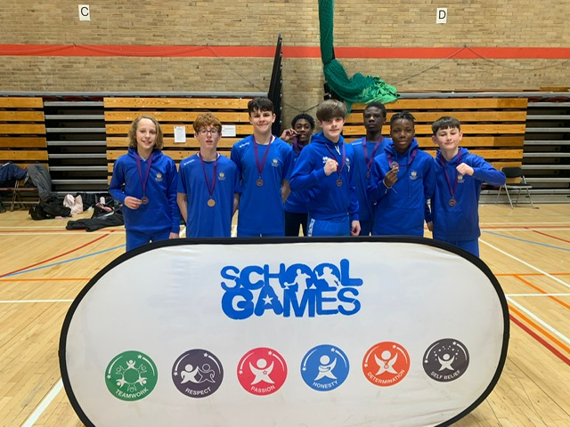
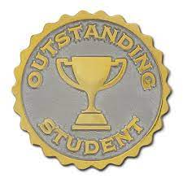
Level 3 Athletics
Year 8 boys represented the Academy at the Sports Hall Athletics School Games held at Newton Aycliffe Leisure Centre in February having won the local event in November. They competed against other schools in the county such as Tanfield and Easington. They worked hard with some fantastic individual performances and finished 3rd overall. Well done to all the boys!

KS3 Curriculum (April-May)

GIRLS – Football and Athletics.
BOYS – Softball and Athletics

